Theaster Gates

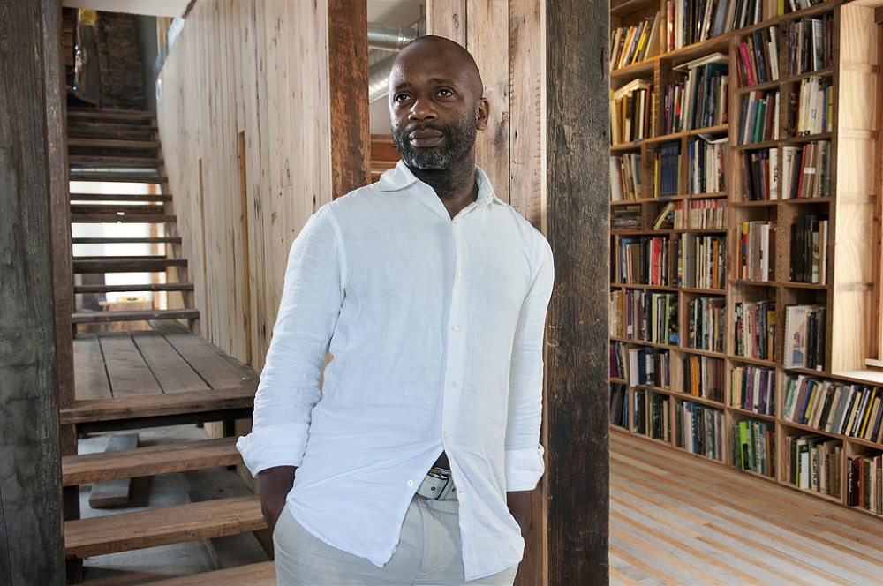

- Born and raised on the West Side of Chicago
- Urban Planning major with a background in Religious Studies and Ceramics
- Does a lot of work to benefit the art community as a whole
- Includes Performance in a lot of his works as a way to communicate with the people

